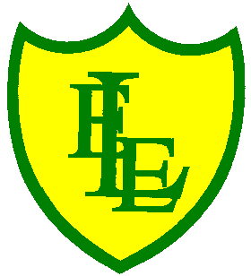
ECCLESTON LANE ENDS
SCHOOL CLOSURE WORK

YEAR: 2
DATE: Monday 30th March 2020

PE: 9-9.30am
Log in to YouTube at 9am to access a 30 minute PE lesson with Joe Wicks, the body coach. https://www.youtube.com/user/thebodycoach1

Reading
Remember in Year 2 we should be reading at home as much as possible but preferably for 15-20 minutes every day. This should be a book that you read for pleasure.
This week we have also set you a reading activity on purple mash (see the 2Do section).
We have allocated you the story ‘Skyscraping Sunflowers’. Please read a chapter each day then complete the short quiz and activities (please find the Reading Detective activity on our class page on the website) about what you have read. Today is Chapter 1.
https://www.purplemash.com/

Spellings

For last week’s spellings - Check out the spelling quiz in the new spelling blog.

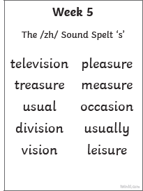

This week’s spellings are:

Please continue to practise your spellings using the spellwell activities in the front of your homework book.

English

This week we will focus on Dinosaurs
Listen to the online story of Julia Donaldson story. Think about what story it is? It is a non-fiction book, fiction? A poem?
https://www.youtube.com/watch?v=tfvv9GLmaUM&t=20s

Your task today is to create a kind of dinosaur and label it. Draw it on paper or design it on the computer, it’s up to you! Think about how it will move, can it fly? Does it roar loudly? What about the size? What’s the colour of the dinosaur? Can it do something that no other dinosaur can do? Is it a carnivore? Herbivore? An Omnivore? (We have already looked at this in Science and what these categories mean)
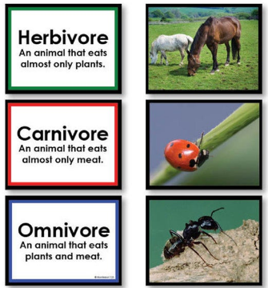

You also need to think of a new name but it has to end with SAURS!
Example of my new dinosaur’s name is Parkeyclarkeysaurs.
Once you have finished your task, listen to the Tyrannosaurus Drip song. This song is sung by the author of the story Julia Donaldson and her husband. The song is all about not fitting in. It is not often you see an author also singing about one of their stories! Enjoy.
https://www.youtube.com/watch?v=y7N_yYktD48

JUST FOR FUN! We have included a spot the difference of a dinosaur landscape. There are 6 differences, can you spot them? Answers will be revealed tomorrow. Happy spotting!

Maths

Today we are going to look at making equivalent (equal) fractions. In class we have learnt that ½ is equal to 2/4. For example:

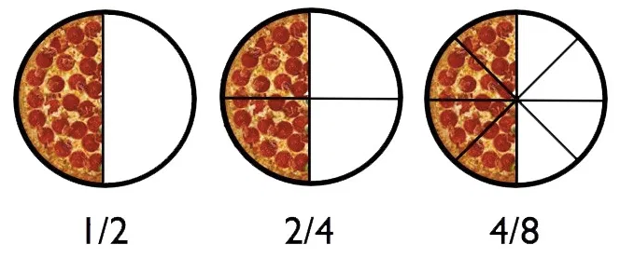 Looking at this image it can also be equal to 4/8.

So what is an equivalent fraction?
If two fractions are equivalent, it means that they are equal, or represent the same value.
How do I find an equivalent fraction?
A good way to learn equivalent fractions is by looking at fraction strips.

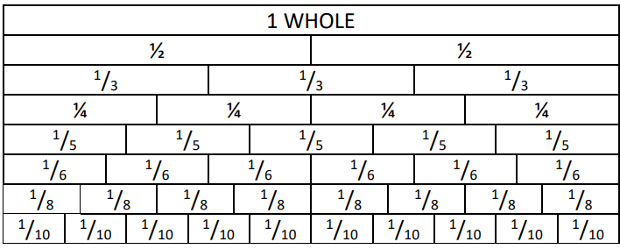

Today’s activity is to use the fraction wall and work out different equal fractions. (see the attached sheet –equlivent fraction wall and complete in you maths home learning book).
Challenge – why don’t you draw these fractions out using pizza slices to check that both fractions are equal to one another?

Science
Please find your Science activity on Purple Mash in the 2Do section. You can do this activity over 2 days (Mon 30th & Tue 31st). Use the interactive activity to choose 3 materials and describe their properties. This task is reviewing your learning from your Science work last half term.

We hope you have had a lovely weekend; it’s a new week and a new set of challenges. Keep inspiring yourselves with your work as the teachers are at home and in school still working hard to provide all your home learning. Let us know what you have been up to via our blog on the website. It doesn’t have to be about school work. It’s always nice to hear from you. You can upload any pictures to our school twitter page to @ecclaneends



