## ECCLESTON LANE ENDS

## *‘Working with each other and for each other’*



***Enjoy the newsletter-Mrs Gowan and the E.L.E. Team***

# Latest News

Newsletter

January/February

2019-20

## Foodbank Donations

Thank you to reception, Year 1 and Year 2 who have all donated to the St Helens Foodbank already. The next collection is from Year 3 on Friday 28th February.

## Judo

Lots of our KS1 children enjoyed their after school club Judo classes during the Spring 1 half term. The coach reported that they were amazing. Well done Judo Club!



## Year 1 Phonics

The Y1 parents’ information evening on 7th January was very well received! Thank you for supporting the partnership between home and school which leads to such great results. Last year we were in the top 5% of primary schools nationally for phonics results!



## Swimming

Years 4 and 6 attended swimming lessons earlier this term. The blocking of swimming daily, although exhausting, has a very positive impact. Some children were able to swim for the very first time as a result. These children were rightly bursting with pride and achievement in learning this life- long skill.



## Debating Competition

We are part of a learning network with six other schools. Recently our fabulous year 6 children won a debating competition in this group. Our pupils were articulate, reasonable and knowledgeable in airing their thoughts and opinions. Well done to Sophie W, Daniel, Jordi and Trudy as debating champions 2020!

## OFSTED says…

## Eccleston Lane Ends is OUTSTANDING in all areas

## Spring 2 VALUE is…

KINDNESS

## Spring 2 COMPOSER is…

ELGAR

## School improvement focus is…

READING

## Diary Dates… February/March 2020

|  |  |  |  |
| --- | --- | --- | --- |
|  |  |  |  |
| Mon 24.02 | School opens for Spring 2 Term. Welcome back!  8am Football Club YR,Y1  Scholastic Book Fair in Y2 classroom 3.15-4pm every day | Fri 6.03 | International Day. Come to school in holiday clothes.  S4YC Football Club Y1,2,3,4 3.15-4.15pm |
| Tues 25.02 | 8am Football Club Y2,Y3 | Mon 9.03 | 8am Football Club YR,Y1  Violin workshops YR,1,2,3  Archery Club Y3,4,5,6 3.15-4.15pm |
| Wed 26.02 | 8am Dodgeball Club Y4, 5,6  Dodgeball Club 3.15-4.15pm Y1,2,3  Ash Wednesday activities at St James Church Y1 9.30am, Y2 1.30pm Parents welcome to join in the fun! | Tues 10.03 | 8am Football Club Y2,Y3  Y6 Maths SATs Booster classes 3.15-4.15pm |
| Thurs 27.02 | 8am Multi-skills Club YR, 1,2  Benchball Club 3.15-4.15pm Y3,4,5,6  PE Kit Challenge winners from Spring 1 to wear clothes of choice to school | Wed 11.03 | 8am Dodgeball Club Y4, 5,6  Dodgeball Club 3.15-4.15pm Y1,2,3 |
| Fri 28.02 | Funky Feet Friday winners from Spring 1 to wear footwear of choice  Year 3 to bring foodbank items in for local charity today please  S4YC Football Club Y1,2,3,4 3.15-4.15pm | Thurs 12.03 | 8am Multi-skills Club YR, 1,2  Benchball Club 3.15-4.15pm Y3,4,5,6  PTA Velocity Event (ELE Big Bounce) 5-6pm |
| Mon 2.03 | 8am Football Club YR,Y1  Archery Club Y3,4,5,6 3.15-4.15pm | Fri 13.03 | S4YC Football Club Y1,2,3,4 3.15-4.15pm |
| Tues 3.03 | 8am Football Club Y2,Y3  Y4 trip to Liverpool Philharmonic | Mon 16.03 | 8am Football Club YR,Y1  Archery Club Y3,4,5,6 3.15-4.15pm  Go Green week  Violin workshops Y4,5,6 |
| Wed 4.03 | 8am Dodgeball Club Y4, 5,6  Dodgeball Club 3.15-4.15pm Y1,2,3  PTA 6.30pm All very welcome including children! | Tues 17.03 | 8am Football Club Y2,Y3  Y6 Maths SATs Booster classes 3.15-4.15pm |
| Thurs 5.03 | 8am Multi-skills Club YR, 1,2  Benchball Club 3.15-4.15pm Y3,4,5,6  World Book Day-see reading newsletter | Wed 18.03 | 8am Dodgeball Club Y4, 5,6  Dodgeball Club 3.15-4.15pm Y1,2,3 |

  Save the Children Christmas Jumper Day

## ECCLESTON LANE ENDS

## *‘Working with each other and for each other’*

blockpage[1]

## Velocity

Due to popular demand the ELE Big Bounce is back! On Thursday 12th March Velocity will be open to ELE only from 5-6pm. Look out for the PTA letter after half term to book your place.

## Reading

Look out for the termly reading newsletter. Let’s all get excited about reading. THE MORE YOU READ THE CLEVERER YOU GET!!!

Infants don’t forget to nurture your adopted pet. Remember to keep it alive and well it must be read to everyday for 15 minutes. There’s a hot chocolate treat waiting if you are a good pet owner!



## Living History Workshops

Children in Year 1 were treated to a ‘Toys’ themed workshop from the Living History Company. It enabled them to develop their history skills in an age appropriate way with a theme that they can relate to.

Year 4 also enjoyed a workshop making their Ancient Egyptians history topic come alive.

## Animals, Animals, Animals!

Reception children have been following their interests to help with their learning. They have had a ‘vets’ role play area; a visit to Chester Zoo and a speaker from Knowsley Safari Park telling the children all about conservation and what we can do to make our planet more sustainable. Why not quiz them about the dangers to bush dogs?

## PTA Monthly Draw

Congratulations to Harriet in YR who has won £25 in the PTA February draw with no 9 and Isla in Y1 who won the January draw with no 34. Happy spending!

## Fire Evacuation

To keep our children, staff and community safe we have a termly fire evacuation practice. Our children are superb at this-they are calm and understand its importance. Current whole school evacuation times are just over one minute-superb! We also test the alarm system weekly whilst the children are in school to ensure everything is in good working order. Mr Lewis, our amazing caretaker does an incredible job of checking that all of our systems function as they should-he multi tasks as our DJ for school discos too! WOW-thanks Mr Lewis!

## Global Belly Laughing Day

We all had fun telling jokes to each other on Friday 24th January as part of Global Belly Laughing Day. A good giggle really does lift everyone’s spirits!

Mrs Gowan’s joke was…

What’s a dogs favourite part of a house?-The woof! Roof-do you get it? Ha ha!!!



## Quality Mark

We are so proud of the recognition of achieving, once again, the Quality Mark for excellence in English and Mathematics. A huge thank you to Miss Bond who led our team in collecting the evidence base for the assessor. Thank you to the pupils, staff, parents and governors who really impressed the assessor.

We wore our

## Road Safety

We hope you enjoyed the poem from our Junior Road Safety Officers and the School Council about road safety. Our JRSOs from Y6 Jordi and Luc delivered a super assembly about how to keep safe on the roads. All of this hard work needs your help please families. Please remind everyone about not dropping off outside school. The walking bus is available to everyone at 8.15am from The Grapes each Tuesday and Friday. This is a healthy way to start the day and leads to less cars around our school.

The **car park** is for **STAFF ONLY** from 8.00am to 5pm with the exception of blue badge holders for our children with disabilities.

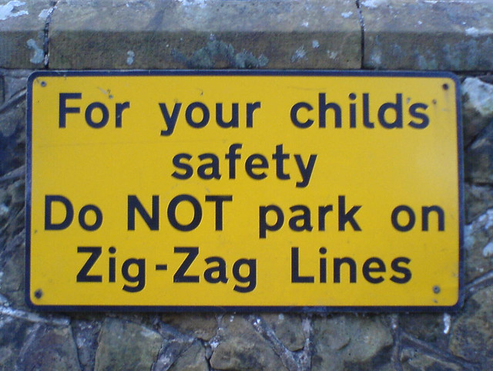

## Yoga and Positive Wellbeing

Ask the children about their yoga sessions in school. The staff have all been trained to deliver sessions by Dr Helen Mills over the last half term. The children have really enjoyed her sessions and it has brought a sense of calm and positive mental and physical wellbeing to school.



## Social Media

Social media is a powerful and wonderful communication tool if used well. Please be reminded however that any discussions around school should be respectful. Any negative comments about staff, pupils and school can be hurtful and have a negative effect. Thank you for using appropriately!

## Contact Us

**Albany Avenue  
Eccleston Park  
Prescot  
Merseyside  
L34 2QN**

**01744 678270**

[www.ecclestonlaneends.st-helens.sch.uk](http://www.ecclestonlaneends.st-helens.sch.uk)

## Latest News…

**Grade Level News**

**Page 3 of 4**