## ECCLESTON LANE ENDS

## *‘Working with each other and for each other’*



## Diary Dates… November/December 2019

***Enjoy the newsletter-Mrs Gowan and the E.L.E. Team***

# Latest News

Newsletter

November/December

2019-20

## Foodbank Donations

Reception children were delighted that the whole school got to see their food bank donations during assembly. All donations go to families in St Helens. Thank you Reception families. The next collection is from Year 2 on Friday 24th January.

## Staff News

Following a few ‘keep in touch days’, we are delighted to have Miss Bond, our wonderful Deputy Headteacher back with us full time. Mr Loftus has done an excellent job as Acting Deputy during Miss Bond’s maternity leave-thank you! Every member of the staff team have ‘stepped up’ during this period of time and have kept our school running smoothly. I’m so proud of the ELE Team! Sadly, we have had to say goodbye and good luck to Mr Byrne who has taken some of the classes since September. A big welcome to Mrs Lewis who has settled in well to After School Club. We are also pleased to have Miss Luter, a Learning Assistant who Year 1 are looking after since she joined the class recently.

## Year 6 Cinema Visit

Year 6 enjoyed a schools’ screening of The Addams Family on 8th November at Cheshire Oaks.

The PTA brought the cinema experience to ELE earlier this month with both Infants and KS2 enjoying popcorn and other treats whist watching a movie!

## Remembrance Day

This year to reinforce the work we do for Remembrance Day, we displayed large red poppies around school. The Parish Council kindly donated them to schools in the local area. It is now 80 years since the start of WW11 and we will make sure future generations never forget!



## OFSTED says…

## Eccleston Lane Ends is OUTSTANDING in all areas!

## Autumn 2 VALUE is…

COOPERATION

|  |  |  |  |
| --- | --- | --- | --- |
|  |  |  |  |
| Fri 29.11.19 | Talent Assembly a.m.  S4YC Football Club 3.15-4.15pm wk4/6 | Fri 13.12.19 | Christmas Jumper Day-please donate £1 to Save the Children  PTA Christmas Fair-open to parents from 3.15-4.30pm  Chn to bring pocket money in morning. |
| Mon 2.12.19 | School assessment week | Mon 16.12.19 | Whole school trip to panto |
| Wed 4.12.19 | 8am Dodgeball Club Y4/5/6  Experience Christmas at St James for Infants  Gym Club 3.15-4.15pm Y1/2/3  PTA 6.30pm All welcome! | Tues 17.12.19 | Infant Christmas Party. Come dressed in party clothes. |
| Thurs 5.12.19 | 8am Dodgeball Y1/2/3  Experience Christmas at St James for Infants  Y2 Eccleston Library for Christmas tree lighting  Year 4 to SAINTS for Rugby Sky Try a.m.  Gym Club Y4/5/6 3.15-4.15pm | Wed 18.12.19 | 8am Dodgeball Club-final session  Years 5 and 6 Christmas Party. Come dressed in party clothes.  Gym Club Y1/2/3 3.15-4.15pm-final session |
| Fri 6.12.19 | Dress rehearsals for Christmas plays  Bottle donations for Christmas Fair please  S4YC Football Club 3.15-4.15pm wk5/6  Dance Club 3.15-4pm wk 5/6 | Thurs 19.12.19 | 8am Dodgeball Y1/2/3-final session  Years 3 and 4 Christmas Party. Come dressed in party clothes.  Gym Club Y4/5/6 3.15-4.15pm-final session |
| Mon 9.12.19 | KS2 Production 2pm. Doors open 1.45pm | Fri 20.12.19 | Achievement Assembly a.m.  Whole school Carol Concert at St James Church pm  School closes for Christmas 3.15pm. No ASC.  MERRY CHRISTMAS EVERYONE! |
| Tues 10.12.19 | Infant Nativity 9.30am. Doors open 8.50am.  KS2 Production 2pm. Doors open 1.45pm | Mon 6.01.20 | School opens for Spring 1 Term  HAPPY NEW YEAR! |
| Wed 11.12.19 | 8am Dodgeball Club Y4/5/6  KS2 Production 9.30am. Doors open 8.50am  Infant Nativity 2pm. Doors open 1.45pm.  Year 3 Christingle experience for Children’s Society charity  Gym Club Y1/2/3 3.15-4.15pm | Tues 7.01.20 | KS1 Judo demonstration  Year 1 Phonics Screening Check information session for parents 3.15-4pm |
| Thurs 12.12.19 | 8am Dodgeball Club  PTA non-uniform day in exchange for a tombola item please  Bling Your Bike  KS2 Santa Dash  Christmas lunch  Y2 Christmas singing at Willowbrook Hospice  Y3 classroom will be polling station (Y3 to enter/exit through Y4)  Gym Club 3.15-4.15pm | Wed 8.01.20 | Reception hearing and vision checks |

## Save the Children Christmas Jumper Day

blockpage[1]**Great Fire of London**

Year 2 enjoyed a fabulous workshop from the Living History Company recently. They are doing lots of exciting activities to keep history alive in their class.

## Times Tables Rockstars

The competition appears to have grown and continues to get great results. Keep up the hard work everyone- it is having a positive impact.

## Year 5 Crucial Crew

Year 5 enjoyed workshops from our emergency services earlier this month known as Crucial Crew. Important safety messages should have a good effect on health, safety and wellbeing.

## Velocity

Thank you to the PTA for organising the ELE Big Bounce. It was a new venture and a very successful activity. Hopefully everyone had lots of jumping fun!

## Starbooks

The children are telling us that the hot chocolate incentive to read more in KS2 is working. Obviously we want all children to love books and read for absolute pleasure-but the chocolate treat seems to hit the spot!

Keep **READING** preferably every day please as this is our whole school area for improvement this year.C:\Users\carol.gowan\AppData\Local\Microsoft\Windows\Temporary Internet Files\Content.IE5\NRBXOFOS\starbucks_iced_mocha_by_chris11art[1].gifC:\Users\carol.gowan\AppData\Local\Microsoft\Windows\Temporary Internet Files\Content.IE5\N4QR7SC6\starbucks_iced_mocha_by_chris11art[1].gif We are launching another reading incentive to the Infants in the New Year.

C:\Users\carol.gowan\AppData\Local\Microsoft\Windows\Temporary Internet Files\Content.IE5\NRBXOFOS\starbucks_iced_mocha_by_chris11art[1].gifC:\Users\carol.gowan\AppData\Local\Microsoft\Windows\Temporary Internet Files\Content.IE5\N4QR7SC6\starbucks_iced_mocha_by_chris11art[1].gif







## ECCLESTON LANE ENDS

## *‘Working with each other and for each other’*

## PTA Monthly Draw

Congratulations toEmily Gibson in YR who won £25 in the PTA October draw. Congratulations to Carter Kellegher also in YR who won November’s draw.

## Spelling Bee

The KS2 termly Spelling Bee took place in November. Well done to everyone who tried hard and entered the competition. Congratulations to the winners as follows:

**Year 3**: Emily Johnson

**Year 4**: Niamh Whittaker

**Year 5:** Alex Simms

**Year 6**: Oliver Johnson

**Overall KS2 spelling winner:** Oliver Johnson

## Arithmetic Ace

The KS2 termly Arithmetic Ace also took place in November. Congratulations mathemagicians!

**Year 3:** Jack Desmond

**Year 4**: Emily Ward

**Year 5**: Isabelle Waite

**Year 6**: Daniel Burdin

**Overall KS2 Arithmetic Ace**: Emily Ward

## Children In Need

The School Council thought of this year’s theme of going spotty or dressing as a superhero. There was also a competition to design a superhero outfit for Pudsey. Thank you for your generous donations. We were able to send £337.66 to this worthwhile charity.



We wore our Christmas jumpers with pride and raised £160.30 for Save

## Contact Us

**Albany Avenue  
Eccleston Park  
Prescot  
Merseyside  
L34 2QN**

**01744 678270**

[www.ecclestonlaneends.st-helens.sch.uk](http://www.ecclestonlaneends.st-helens.sch.uk)

## Anti-Bullying

Thank you for encouraging the children to wear odd socks on Tuesday 12th November. This is to raise awareness about bullying. Bullying in any form should be stamped out. We are committed to teaching our pupils about friendships, diversity, positive relationships, respect and tolerance. Bullying at ELE will not be tolerated. TELL, TELL, TELL is the BIG message. We promise to deal with any form of bullying at our school so everyone can continue to feel safe and happy.

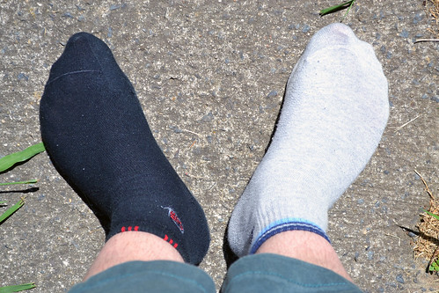

## NHS Help!

Look out for this booklet in children’s bags. It explains how we can all keep our NHS working effectively in winter by making the right choices when feeling ill.

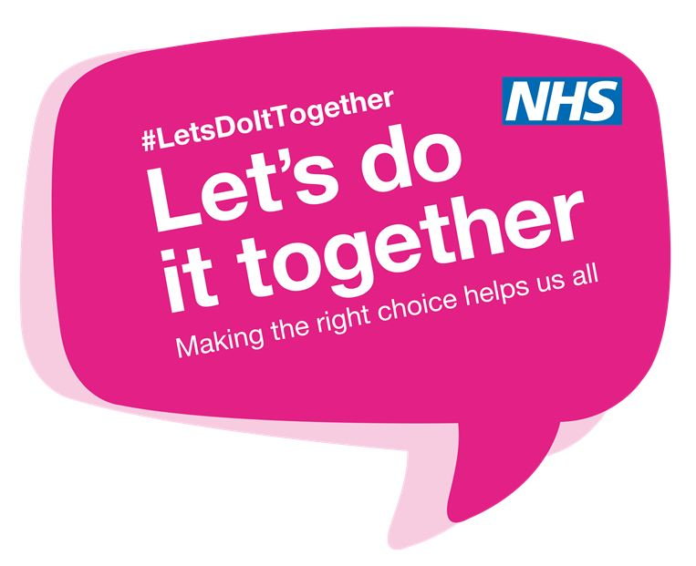

## Social Media

Social media is a powerful and wonderful communication tool if used well. Please be reminded however that any discussions around school should be respectful. Any negative comments about staff, pupils and school can be hurtful and have a negative effect. Thank you for using appropriately!

## Latest News…

**Grade Level News**

**Page 3 of 4**